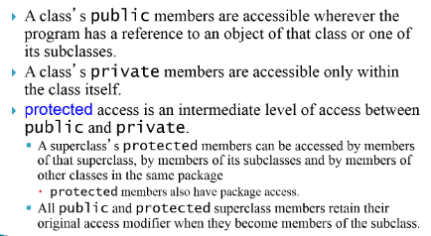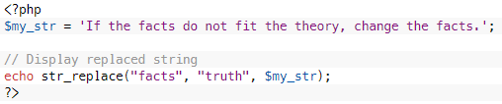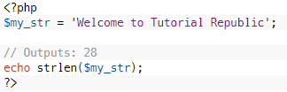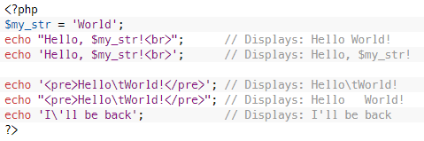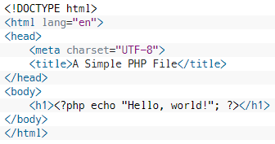A screenshot of a cell phone

Description generated with very high confidence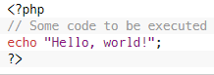A screenshot of a cell phone

Description generated with very high confidenceA screenshot of a cell phone

Description generated with very high confidenceA screenshot of a cell phone

Description generated with very high confidence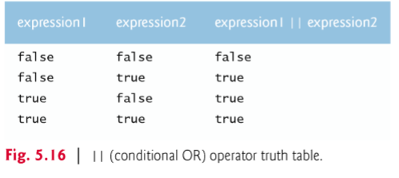A screenshot of a cell phone

Description generated with very high confidenceA picture containing person, text

Description generated with high confidenceA close up of a person

Description generated with high confidenceA screenshot of a cell phone

Description generated with very high confidenceA screenshot of a cell phone

Description generated with very high confidence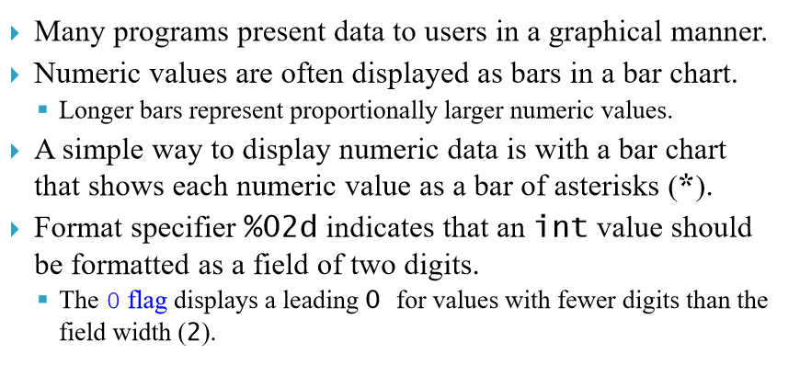A screenshot of a cell phone

Description generated with very high confidence

Arrays